Learners have to come up with a Report to support the answers to the following questions and suggestions

Objective Questions

- List the different types of columns in table “ball_by_ball” (using information schema).
SELECT
column_name,
data_type
FROM information_schema.columns
WHERE table_name = 'ball_by_ball';
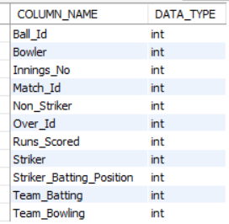

The output shows that the ball_by_ball table contains columns such as Ball_Id, Bowler, Innings_No, Match_Id, Non_Striker, Over_Id, Runs_Scored, Striker, Striker_Batting_Position, Team_Batting, and Team_Bowling. All these columns have the INT data type, indicating that they store numeric values. This confirms that the table mainly contains numerical match and ball-by-ball information used for cricket match analysis.

- What is the total number of runs scored in 1st season by RCB (bonus: also include the extra runs using the extra runs table) ?
SELECT
SUM(b.Runs_Scored) + COALESCE(SUM(e.Extra_Runs),0) AS Total_Runs
FROM matches m
JOIN ball_by_ball b
ON m.Match_Id = b.Match_Id
LEFT JOIN extra_runs e
ON b.Match_Id = e.Match_Id
AND b.Over_Id = e.Over_Id
AND b.Ball_Id = e.Ball_Id
AND b.Innings_No = e.Innings_No
WHERE m.Season_Id = 6
AND b.Team_Batting = 2;



RCB maintained a strong batting contribution in the season with a cumulative score of 2601 runs.
Including extra runs gives a more realistic representation of the team's total scoring performance.
This analysis can be further extended to compare RCB's performance with other IPL teams across seasons.

- How many players were more than the age of 25 during season 2014?
SELECT COUNT(*) AS Players_Above_25
FROM player
WHERE TIMESTAMPDIFF(YEAR, DOB, '2014-01-01') > 25;



During the 2014 season, 321 players were older than 25 years. This indicates that the tournament consisted largely of experienced players, contributing to team stability and overall performance.

- How many matches did RCB win in 2013?
select count(*) as RCB_Wins
from matches m
join season s
on m.Season_Id = s.Season_Id
where s.Season_Year = 2013
AND m.Match_Winner = 2;

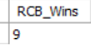

The analysis shows that Royal Challengers Bangalore (RCB) secured 9 victories in the 2013 IPL season. This indicates that the team performed competitively and remained a strong contender throughout the tournament.
Team: Royal Challengers Bangalore (RCB)
Season: 2013
Total Matches Won: 9

- List the top 10 players according to their strike rate in the last 4 seasons?

SELECT
p.Player_Name,
SUM(b.Runs_Scored) AS Total_Runs,
COUNT(*) AS Balls_Faced,
ROUND((SUM(b.Runs_Scored) * 100.0) / COUNT(*), 2) AS Strike_Rate
FROM ball_by_ball b
JOIN matches m
ON b.Match_Id = m.Match_Id
JOIN player p
ON b.Striker = p.Player_Id
WHERE m.Season_Id IN (6,7,8,9)
GROUP BY p.Player_Id, p.Player_Name
HAVING COUNT(*) > 0
ORDER BY Strike_Rate DESC
LIMIT 10;

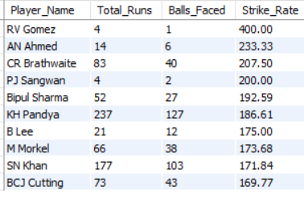
Visualization:-

RV Gomez recorded the highest strike rate of 400.00.
AN Ahmed achieved a strike rate of 233.33.
CR Brathwaite maintained an impressive strike rate of 207.50.
Players such as KH Pandya and BCJ Cutting also demonstrated strong scoring efficiency.

The analysis highlights the most explosive batsmen from the last four IPL seasons. Teams can use strike rate as a key performance indicator while selecting players for aggressive batting roles and match-winning situations.

- What are the average runs scored by each batsman considering all the seasons?
SELECT
p.Player_Name,
round(AVG(b.Runs_Scored),2) AS Avg_Runs
FROM ball_by_ball b
join player p
ON b.Striker = p.Player_Id
GROUP BY p.Player_Id, p.Player_Name
order by Avg_Runs DESC;

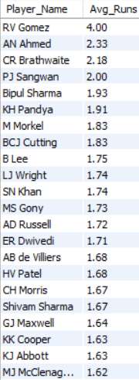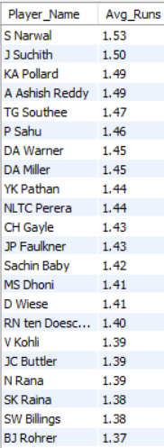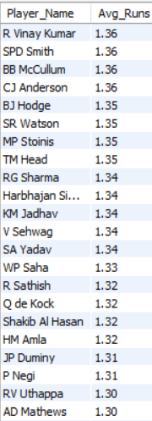

Visualization:-

High average runs per ball indicate a player's ability to score quickly and maximize team runs.
Such batsmen can be valuable in T20 cricket, especially during powerplay and death overs where rapid scoring is crucial.
Teams can use this analysis to identify impact players and optimize batting order strategies.

- What are the average wickets taken by each bowler considering all the seasons?
select p.Player_Name,
round(COUNT(*)*1.0 / COUNT(DISTINCT m.Season_id),2) AS Avg_Wickets
FROM wicket_taken w
join ball_by_ball b
ON w.Match_Id = b.Match_Id
AND w.Over_Id = b.Over_Id
AND w.Ball_Id = b.Ball_Id
join player P
ON b.Bowler = p.Player_id
join matches m
on w.Match_Id = m.Match_Id
group by p.Player_Id, p.Player_Name
order by Avg_Wickets DESC;

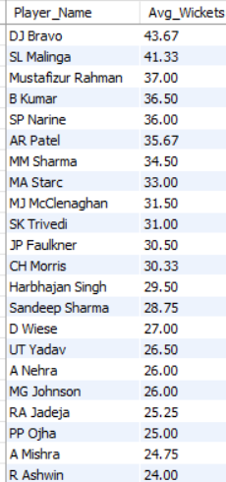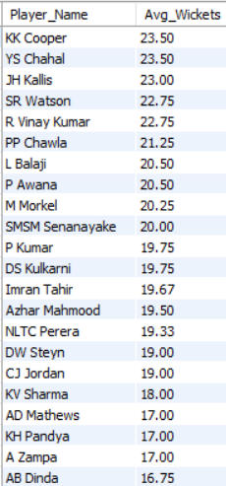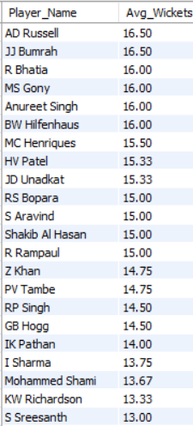

Visualization:-

DJ Bravo emerged as the most successful wicket-taking bowler on average across all seasons, followed closely by SL Malinga. Their performances highlight the importance of experienced bowlers in influencing match results and maintaining bowling dominance throughout the IPL.

- List all the players who have average runs scored greater than the overall average and who have taken wickets greater than the overall average.
WITH batting AS (
SELECT
p.Player_Id,
p.Player_Name,
AVG(b.Runs_Scored) AS Avg_Runs
FROM player p
JOIN ball_by_ball b
ON p.Player_Id = b.Striker
GROUP BY p.Player_Id, p.Player_Name
),
bowling AS (
SELECT
p.Player_Id,
COUNT(*) AS Total_Wickets
FROM player p
JOIN ball_by_ball b
ON p.Player_Id = b.Bowler
JOIN wicket_taken w
ON b.Match_Id = w.Match_Id
AND b.Over_Id = w.Over_Id
AND b.Ball_Id = w.Ball_Id
GROUP BY p.Player_Id
)

SELECT
bt.Player_Name,
bt.Avg_Runs,
bw.Total_Wickets
FROM batting bt
JOIN bowling bw
ON bt.Player_Id = bw.Player_Id
WHERE bt.Avg_Runs >
(SELECT AVG(Runs_Scored) FROM ball_by_ball)
AND bw.Total_Wickets >
(
SELECT AVG(wicket_count)
FROM (
SELECT COUNT(*) AS wicket_count
FROM wicket_taken
GROUP BY Player_Out
) x
)
ORDER BY bt.Avg_Runs DESC, bw.Total_Wickets DESC;

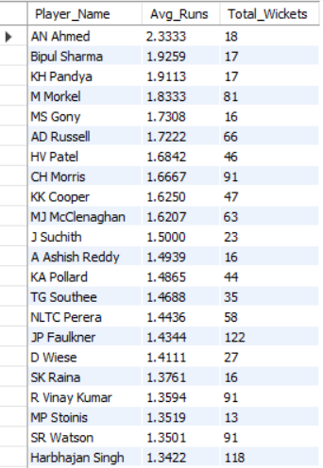

Visualization:-

The analysis identifies players who contribute significantly with both bat and ball, making them valuable all-rounders.
From the results, JP Faulkner (122 wickets), Harbhajan Singh (118 wickets), CH Morris (91 wickets), SR Watson (91 wickets), R Vinay Kumar (91 wickets), M Morkel (81 wickets), and AD Russell (66 wickets) stand out as the strongest dual contributors. These players have maintained above-average batting performance while also taking more wickets than the overall bowling average.
Conclusion:
The best all-round options are JP Faulkner, Harbhajan Singh, SR Watson, CH Morris, AD Russell, and KA Pollard, as they contribute effectively with both bat and ball. Such players improve team balance, provide strategic flexibility, and increase the chances of winning matches in different situations.

- Create a table rcb_record table that shows the wins and losses of RCB in an individual venue.
SELECT
v.Venue_Name,
SUM(CASE WHEN m.Match_Winner = 2 THEN 1 ELSE 0 END) AS Wins,
SUM(CASE
WHEN (m.Team_1 = 2 OR m.Team_2 = 2)
AND m.Match_Winner <> 2
THEN 1
ELSE 0
END) AS Losses
FROM matches m
JOIN venue v
ON m.Venue_Id = v.Venue_Id
WHERE m.Team_1 = 2
OR m.Team_2 = 2
GROUP BY v.Venue_Name
ORDER BY Wins DESC;

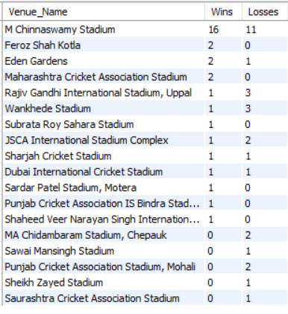
Visualization:-

Best venue for RCB: M. Chinnaswamy Stadium (16 wins).
Strong performance: Feroz Shah Kotla, Eden Gardens, Maharashtra Cricket Association Stadium.
Weak performance: Chepauk, Wankhede Stadium, Rajiv Gandhi International Stadium.
Home advantage plays a significant role in RCB's success.
Venue-specific performance analysis can help optimize team strategy and player selection for future matches.

- What is the impact of bowling style on wickets taken?
select
bs.Bowling_skill AS Bowling_Style,
COUNT(*) AS Total_Wickets
FROM wicket_taken w
join ball_by_ball b
ON w.Match_Id = b.Match_Id
AND w.Over_Id = b.Over_Id
AND w.Ball_Id = b.Ball_Id
JOIN player p
on b.Bowler = p.Player_Id
join bowling_style bs
on p.Bowling_skill = bs.Bowling_Id
group by bs.Bowling_skill
order by Total_Wickets DESC;
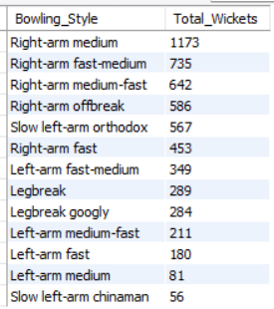

Visualization:-

The analysis shows that Right-arm medium bowlers have taken the highest number of wickets (1173 wickets), making them the most successful bowling style in the dataset. They are followed by Right-arm fast-medium (735 wickets) and Right-arm medium-fast (642 wickets) bowlers.
Among spin bowlers, Right-arm offbreak (586 wickets) and Slow left-arm orthodox (567 wickets) have performed exceptionally well, indicating that spin bowling also plays a crucial role in wicket-taking.

- Write the SQL query to provide a status of whether the performance of the team is better than the previous year's performance on the basis of the number of runs scored by the team in the season and the number of wickets taken.

WITH season_stats AS
(
SELECT
m.Season_Id,
b.Team_Batting AS Team_Id,
SUM(b.Runs_Scored + IFNULL(er.Extra_Runs,0)) AS Total_Runs,
COUNT(w.Player_Out) AS Total_Wickets
FROM ball_by_ball b
JOIN matches m
ON b.Match_Id = m.Match_Id
LEFT JOIN extra_runs er
ON b.Match_Id = er.Match_Id
AND b.Over_Id = er.Over_Id
AND b.Ball_Id = er.Ball_Id
LEFT JOIN wicket_taken w
ON b.Match_Id = w.Match_Id
AND b.Over_Id = w.Over_Id
AND b.Ball_Id = w.Ball_Id
GROUP BY m.Season_Id, b.Team_Batting
)

SELECT
Season_Id,
Team_Id,
Total_Runs,
Total_Wickets,
CASE
WHEN Total_Runs >
LAG(Total_Runs) OVER(PARTITION BY Team_Id ORDER BY Season_Id)
AND Total_Wickets >
LAG(Total_Wickets) OVER(PARTITION BY Team_Id ORDER BY Season_Id)
THEN 'Better'

WHEN Total_Runs <
LAG(Total_Runs) OVER(PARTITION BY Team_Id ORDER BY Season_Id)
AND Total_Wickets <
LAG(Total_Wickets) OVER(PARTITION BY Team_Id ORDER BY Season_Id)
THEN 'Worse'

ELSE 'Mixed'
END AS Performance_Status
FROM season_stats;
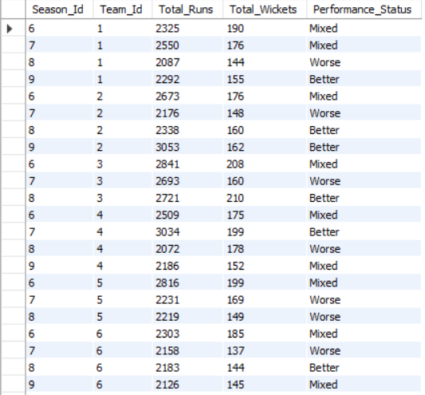
Visualation:-

Comparing teams with their previous seasons provides a clear view of performance trends. Teams categorized as Better have successfully improved their overall game, while Worse teams need attention in key performance areas. The Mixed category highlights teams that improved in one aspect but still have room for improvement in another.

- Can you derive more KPIs for the team strategy?

KPIs :-
Net Run Rate (NRR) – Measures overall team performance across the season.
Batting Strike Rate – Average scoring speed of the batting lineup.
Bowling Strike Rate – Average balls required to take a wicket.
Boundary Percentage – Percentage of runs scored through fours and sixes.
Dot Ball Percentage – Percentage of deliveries where no runs were scored.
Average Partnership Runs – Average runs added per wicket partnership.
Top Order Contribution – Runs scored by the top 3 batsmen.
Middle Order Contribution – Runs scored by batsmen at positions 4–7.
Death Overs Bowling Economy – Economy rate in the last five overs.
Powerplay Wickets Taken – Wickets picked up during the first six overs.
Home vs Away Win Percentage – Performance comparison at home and away venues.
Player of the Match Contribution – Number of awards won by players from the team.
Fielding Efficiency – Catches, run-outs, and stumpings completed.
Winning Margin Analysis – Average margin of victory by runs or wickets.
Close Match Success Rate – Win percentage in matches decided by fewer than 10 runs or 3 wickets.
Batting First vs Chasing Performance – Comparison of wins in both situations.
Captain's Win Percentage – Team performance under different captains.
Consistency Index – Variation in team scores across matches.
Opponent-wise Win Percentage – Success rate against each opponent.
Playoff Qualification Rate – Percentage of seasons the team reached the playoffs.

Additional KPIs such as win percentage, run rate, wicket-taking efficiency, economy rate, boundary percentage, and venue-wise performance can provide deeper insights into team strategy. These metrics help identify strengths and weaknesses in batting, bowling, and match tactics. By monitoring these KPIs, teams can make better decisions regarding player selection, match strategy, and overall performance improvement.

- Using SQL, write a query to find out the average wickets taken by each bowler in each venue. Also, rank the gender according to the average value.

WITH bowler_venue_stats AS
(
SELECT
v.Venue_Name,
p.Player_Name,
ROUND(COUNT(*) * 1.0 / COUNT(DISTINCT m.Match_Id), 2) AS Avg_Wickets
FROM wicket_taken w
JOIN ball_by_ball b
ON w.Match_Id = b.Match_Id
AND w.Over_Id = b.Over_Id
AND w.Ball_Id = b.Ball_Id
JOIN matches m
ON w.Match_Id = m.Match_Id
JOIN venue v
ON m.Venue_Id = v.Venue_Id
JOIN player p
ON b.Bowler = p.Player_Id
GROUP BY v.Venue_Name, p.Player_Id, p.Player_Name
)

SELECT
Venue_Name,
Player_Name,
Avg_Wickets,
DENSE_RANK() OVER
(
PARTITION BY Venue_Name
ORDER BY Avg_Wickets DESC
) AS Venue_Rank
FROM bowler_venue_stats
ORDER BY Venue_Name, Venue_Rank;
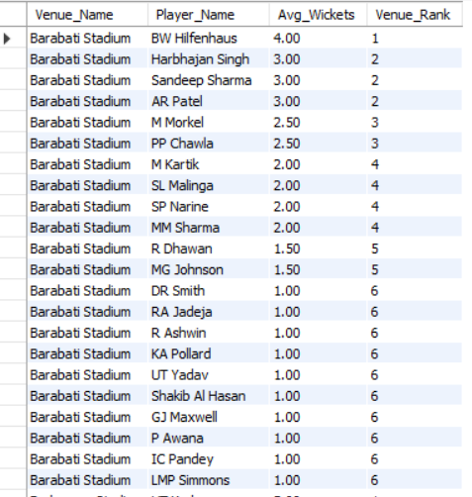

The analysis ranks bowlers based on their average wickets taken at each venue. The results show that bowling performance varies significantly across venues, indicating that pitch conditions and ground characteristics have a strong influence on wicket-taking ability.
At Barabati Stadium, BW Hilfenhaus achieved the highest average wickets (4.00) and secured Rank 1. Bowlers such as Harbhajan Singh, Sandeep Sharma, and AR Patel shared Rank 2 with an average of 3.00 wickets. This suggests that these bowlers were particularly effective under the conditions offered by this venue.

- Which of the given players have consistently performed well in past seasons? (will you use any visualization to solve the problem)?

SELECT
p.Player_Name,
s.Season_Year,
SUM(b.Runs_Scored) AS Total_Runs
FROM ball_by_ball b
JOIN matches m
ON b.Match_Id = m.Match_Id
JOIN season s
ON m.Season_Id = s.Season_Id
JOIN player p
ON b.Striker = p.Player_Id
GROUP BY p.Player_Name, s.Season_Year
ORDER BY p.Player_Name, s.Season_Year;
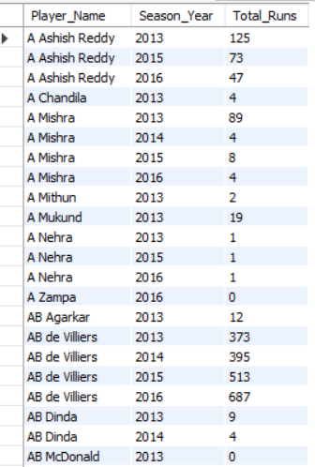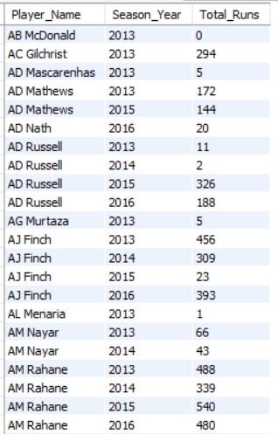

Visualization:-

A Line Chart would be used to analyze season-wise runs scored by each player. Players whose performance remains stable or improves across multiple seasons can be considered consistent performers. The chart helps visualize trends and identify players with sustained performance over time.

- Are there players whose performance is more suited to specific venues or conditions? (how would you present this using charts?)
SELECT
v.Venue_Name, p.Player_Name,
SUM(b.Runs_Scored) AS Total_Runs
FROM ball_by_ball b
JOIN matches m
ON b.Match_Id = m.Match_Id
JOIN venue v
ON m.Venue_Id = v.Venue_Id
JOIN player p
ON b.Striker = p.Player_Id
GROUP BY v.Venue_Name, p.Player_Name
ORDER BY v.Venue_Name, Total_Runs DESC;
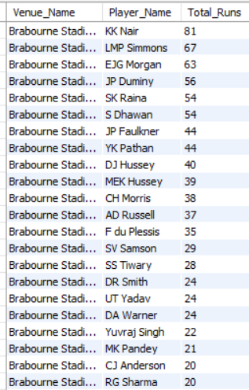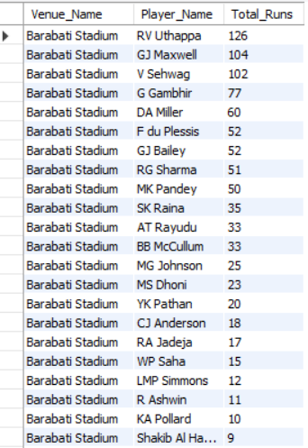
Visualization :-
Clustered column chart
X-Axis = Venue_Name
Y-Axis = Total_Runs
Legend = Player_Name

The analysis shows that some players perform significantly better at certain venues than others. By comparing runs scored across different stadiums, venue-specific strengths can be identified. A Heat Map or Clustered Bar Chart is the most effective way to visualize this relationship, as it clearly highlights which players perform exceptionally well at particular venues. These insights can help teams make better batting-order and venue-specific strategy decisions.

Subjective Questions

- How does the toss decision affect the result of the match? (which visualizations could be used to present your answer better) And is the impact limited to only specific venues?

For Batsman

(SELECT
p.Player_Name,
SUM(b.Runs_Scored) AS Total_Runs
FROM ball_by_ball b
JOIN player p
ON b.Striker = p.Player_Id
GROUP BY p.Player_Id, p.Player_Name
ORDER BY Total_Runs DESC;)
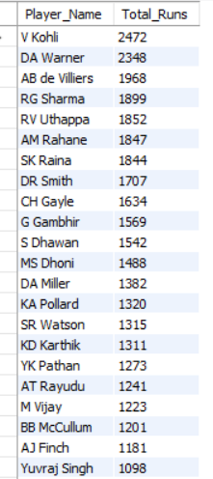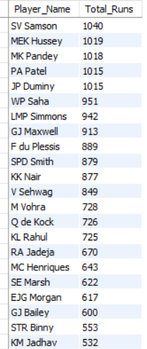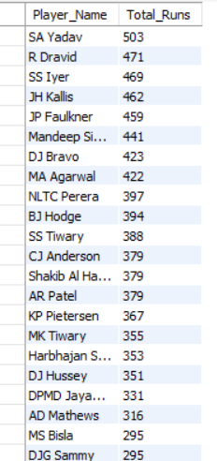

For Bowler
(SELECT
td.Toss_Name,
COUNT(*) AS Total_Matches,
SUM(CASE WHEN m.Toss_Winner = m.Match_Winner THEN 1 ELSE 0 END) AS Toss_Winner_Won,
ROUND(
SUM(CASE WHEN m.Toss_Winner = m.Match_Winner THEN 1 ELSE 0 END) * 100.0
/ COUNT(*), 2
) AS Win_Percentage
FROM matches m
JOIN toss_decision td
ON m.Toss_Decide = td.Toss_Id
GROUP BY td.Toss_Name;)

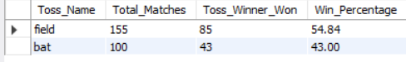

1.Approach:-
Calculated the total runs scored by each batsman using the ball_by_ball table.
Compared the toss decision (Bat or Field) with the final match result.
Counted total matches, matches won by the toss-winning team, and calculated the win percentage.
Analyzed whether the toss decision has a significant impact on the match outcome.

2. Visualization:-

3. Insights:-
Teams choosing to Field First won 85 out of 155 matches, achieving a 54.84% win percentage.
Teams choosing to Bat First won 43 out of 100 matches, achieving a 43.00% win percentage.
Fielding first provides a better chance of winning than batting first.
Virat Kohli (2472 runs) is the highest run scorer, followed by David Warner (2348) and AB de Villiers (1968), showing the importance of strong top-order batting.

4. Recommendations:-
Teams should prefer fielding first after winning the toss, especially on grounds that support chasing.
Build the batting lineup around consistent performers like Virat Kohli.
Analyze venue-specific toss trends before making the toss decision.
Strengthen bowling resources for second-innings defense and chasing scenarios.

5. Conclusion:-
The analysis shows that toss decisions influence match outcomes, with teams choosing to field first achieving a higher win percentage (54.84%) than teams choosing to bat first (43.00%). Along with an effective toss strategy, consistent performances from top batsmen such as Virat Kohli significantly improve a team's chances of winning.

- Suggest some of the players who would be best fit for the team.

WITH batting AS (
SELECT
p.Player_Id,
p.Player_Name,
SUM(b.Runs_Scored) AS Total_Runs
FROM ball_by_ball b
JOIN player p
ON b.Striker = p.Player_Id
GROUP BY p.Player_Id, p.Player_Name
),
bowling AS (
SELECT
p.Player_Id,
COUNT(*) AS Total_Wickets
FROM wicket_taken w
JOIN ball_by_ball b
ON w.Match_Id = b.Match_Id
AND w.Over_Id = b.Over_Id
AND w.Ball_Id = b.Ball_Id
JOIN player p
ON b.Bowler = p.Player_Id
GROUP BY p.Player_Id
)

SELECT
bt.Player_Name,
bt.Total_Runs,
COALESCE(bw.Total_Wickets,0) AS Total_Wickets
FROM batting bt
LEFT JOIN bowling bw
ON bt.Player_Id = bw.Player_Id
ORDER BY bt.Total_Runs DESC,
Total_Wickets DESC;

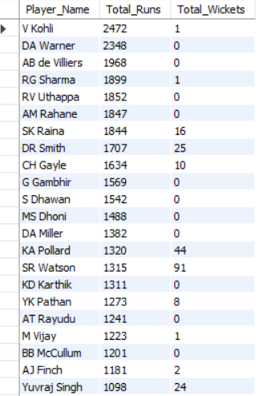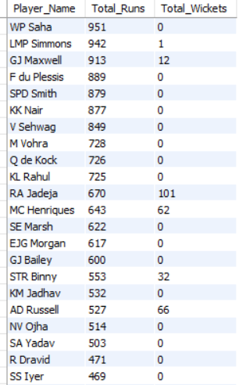

1.Approach:-
To identify the best-fit players, both batting and bowling performances were analyzed together. Players with high run-scoring ability and significant wicket-taking contributions were considered more valuable because they provide balance and flexibility to the team.

2.Visualization:-

3.Insights:-
Based on the output:
Top Specialist Batsmen
V Kohli – 2472 Runs
DA Warner – 2348 Runs
AB de Villiers – 1968 Runs
RG Sharma – 1899 Runs
RV Uthappa – 1852 Runs
These players consistently scored a large number of runs and can strengthen the batting lineup.
Top All-Rounders
SR Watson – 1315 Runs, 91 Wickets
KA Pollard – 1320 Runs, 44 Wickets
RA Jadeja – 670 Runs, 101 Wickets
AD Russell – 527 Runs, 66 Wickets
JP Duminy – 1015 Runs, 24 Wickets
Harbhajan Singh – 353 Runs, 118 Wickets
CH Morris – 285 Runs, 91 Wickets
These players contribute in both departments and provide excellent team balance.
Top Specialist Bowlers
Harbhajan Singh – 118 Wickets
AR Patel – 107 Wickets
RA Jadeja – 101 Wickets
SR Watson – 91 Wickets
CH Morris – 91 Wickets
These bowlers can consistently take wickets and control the game.

4.Recommendations:-
Retain strong run scorers such as V Kohli, DA Warner, and AB de Villiers as the batting core.
Include all-rounders like SR Watson, RA Jadeja, KA Pollard, and AD Russell to improve team balance.
Build the bowling attack around Harbhajan Singh, AR Patel, RA Jadeja, and CH Morris.
Prioritize players who contribute in multiple areas rather than relying only on specialist batsmen or bowlers.

5.Conclusion:-
The most valuable players for the team are SR Watson, RA Jadeja, KA Pollard, AD Russell, CH Morris, and JP Duminy, as they contribute with both bat and ball. Along with top batsmen such as V Kohli, DA Warner, and AB de Villiers, these players create a balanced and competitive team capable of performing consistently across different match situations.

- What are some of the parameters that should be focused on while selecting the players?

WITH batting AS
(
SELECT
p.Player_Id,
p.Player_Name,
SUM(b.Runs_Scored) AS Total_Runs
FROM ball_by_ball b
JOIN player p
ON b.Striker = p.Player_Id
GROUP BY p.Player_Id, p.Player_Name
),

bowling AS
(
SELECT
p.Player_Id,
COUNT(*) AS Total_Wickets
FROM wicket_taken w
JOIN ball_by_ball b
ON w.Match_Id = b.Match_Id
AND w.Over_Id = b.Over_Id
AND w.Ball_Id = b.Ball_Id
JOIN player p
ON b.Bowler = p.Player_Id
GROUP BY p.Player_Id
)

SELECT
bt.Player_Name,
bt.Total_Runs,
COALESCE(bw.Total_Wickets,0) AS Total_Wickets
FROM batting bt
LEFT JOIN bowling bw
ON bt.Player_Id = bw.Player_Id
WHERE COALESCE(bw.Total_Wickets,0) > 0
ORDER BY Total_Runs DESC, Total_Wickets DESC;
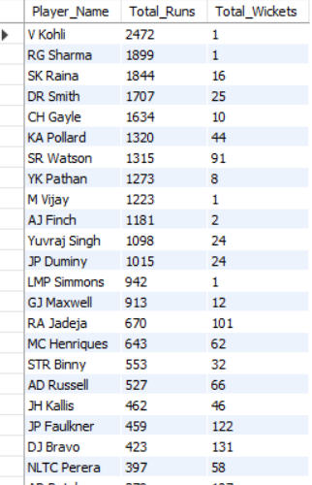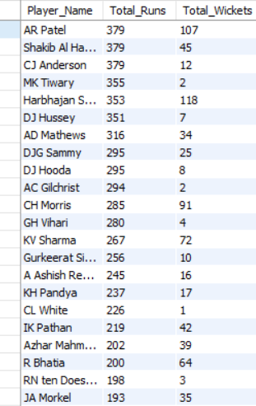

1.Approach:-
The analysis combines batting and bowling performance to identify players who can contribute effectively to the team. Total Runs and Total Wickets were used as the primary performance indicators to evaluate overall player impact.

2.Visualization:-

3.Insights:-
Virat Kohli (2472 Runs), Rohit Sharma (1899 Runs), and Suresh Raina (1844 Runs) were the leading batsmen.
DJ Bravo (131 Wickets), B Kumar (146 Wickets), and JP Faulkner (122 Wickets) were the most successful bowlers.
SR Watson (1315 Runs, 91 Wickets) demonstrated excellent all-round performance.
Ravindra Jadeja (670 Runs, 101 Wickets) provided strong contributions with both bat and ball.
Kieron Pollard, AD Russell, and MC Henriques also showed valuable all-round capabilities.
Players who contribute in multiple areas provide greater value than specialists alone.

4.Recommendations:-
When selecting players, teams should focus on:
Batting Performance (Runs Scored)
Bowling Performance (Wickets Taken)
All-Round Contribution
Consistency Across Matches
Match-Winning Ability
Team Balance
Adaptability to Different Conditions
Performance Under Pressure

5.Conclusion:-
The best player selection strategy should focus on overall contribution rather than a single metric. A balanced combination of strong batsmen, effective bowlers, and reliable all-rounders such as SR Watson, Ravindra Jadeja, Kieron Pollard, and AD Russell can significantly improve a team's chances of success.

- Which players offer versatility in their skills and can contribute effectively with both bat and ball? (can you visualize the data for the same)

WITH batting AS
(
SELECT
Striker AS Player_Id,
SUM(Runs_Scored) AS Total_Runs
FROM ball_by_ball
GROUP BY Striker
),
bowling AS
(
SELECT
b.Bowler AS Player_Id,
COUNT(*) AS Total_Wickets
FROM wicket_taken w
JOIN ball_by_ball b
ON w.Match_Id = b.Match_Id
AND w.Over_Id = b.Over_Id
AND w.Ball_Id = b.Ball_Id
GROUP BY b.Bowler
)

SELECT
p.Player_Name,
bt.Total_Runs,
bw.Total_Wickets
FROM player p
JOIN batting bt
ON p.Player_Id = bt.Player_Id
JOIN bowling bw
ON p.Player_Id = bw.Player_Id
ORDER BY bt.Total_Runs DESC, bw.Total_Wickets DESC;

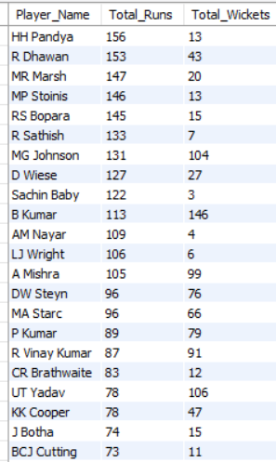

1.Approach:-
To identify versatile players (all-rounders), batting and bowling statistics were combined. Players who contributed with both runs scored and wickets taken were considered valuable all-round performers.

2.Visualization:-
Recommended Chart: Clustered column
X-Axis → Total Runs
Y-Axis → Total Wickets
Each Dot → Player
Players appearing in the upper-right area of the chart represent the strongest all-rounders because they perform well in both batting and bowling.

3.Insights:-
HH Pandya scored 156 runs and took 13 wickets, showing balanced contributions in both departments.
R Dhawan scored 153 runs and took 43 wickets, making him a reliable all-round performer.
MR Marsh contributed 147 runs and 20 wickets, demonstrating versatility.
MP Stoinis scored 146 runs and took 13 wickets, providing value as an all-round player.
MG Johnson contributed 131 runs and 104 wickets, making him one of the most impactful bowling all-rounders.
B Kumar scored 113 runs and took 146 wickets, highlighting exceptional bowling ability along with useful batting contributions.
A Mishra, DW Steyn, MA Starc, and UT Yadav also contributed with both bat and ball.

4.Recommendations:-
Teams should prioritize players who can contribute in multiple areas of the game.
All-rounders increase team flexibility and improve balance in both batting and bowling units.
Players such as R Dhawan, MR Marsh, MP Stoinis, HH Pandya, and B Kumar should be considered valuable assets due to their dual contributions.
A balanced combination of batting all-rounders and bowling all-rounders can strengthen overall team performance.

5.Conclusion:-
The analysis shows that HH Pandya, R Dhawan, MR Marsh, MP Stoinis, MG Johnson, and B Kumar are among the key versatile players in the dataset. Their ability to contribute with both bat and ball makes them important resources for building a balanced and competitive IPL team.

- Are there players whose presence positively influences the morale and performance of the team? (justify your answer using visualization)?

WITH batting AS (
SELECT
Striker AS Player_Id,
SUM(Runs_Scored) AS Total_Runs
FROM ball_by_ball
GROUP BY Striker
),

bowling AS (
SELECT
b.Bowler AS Player_Id,
COUNT(*) AS Total_Wickets
FROM wicket_taken w
JOIN ball_by_ball b
ON w.Match_Id = b.Match_Id
AND w.Over_Id = b.Over_Id
AND w.Ball_Id = b.Ball_Id
GROUP BY b.Bowler
)

SELECT
p.Player_Name,
COALESCE(bt.Total_Runs, 0) AS Total_Runs,
COALESCE(bw.Total_Wickets, 0) AS Total_Wickets
FROM player p
LEFT JOIN batting bt
ON p.Player_Id = bt.Player_Id
LEFT JOIN bowling bw
ON p.Player_Id = bw.Player_Id
WHERE COALESCE(bt.Total_Runs,0) > 500
OR COALESCE(bw.Total_Wickets,0) > 20
ORDER BY Total_Runs DESC, Total_Wickets DESC;

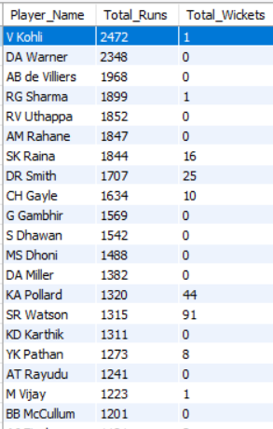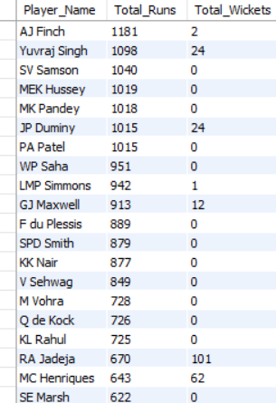

1. Approach:-
The analysis combines batting and bowling statistics to evaluate the overall contribution of each player. Total Runs and Total Wickets were calculated for every player to identify those who consistently perform in multiple departments. Players with significant contributions in both batting and bowling are considered to have a greater positive influence on team morale and overall performance.

2. Visualization:-
Recommended Chart: Bar chart
X-Axis: Total Runs
Y-Axis: Total Wickets
Data Labels: Player Name
Reason:
A Scatter Plot effectively identifies players who contribute in both batting and bowling. Players positioned in the upper-right corner represent the strongest all-round performers and have the greatest impact on team performance.

3. Insights:-
Virat Kohli scored 2472 runs, making him the team's most dependable batsman.
AB de Villiers (1968 runs), David Warner (2348 runs), Rohit Sharma (1899 runs), and Suresh Raina (1844 runs) consistently strengthened the batting lineup.
Shane Watson (1315 Runs, 91 Wickets), Ravindra Jadeja (670 Runs, 101 Wickets), Dwayne Bravo (423 Runs, 131 Wickets), James Faulkner (459 Runs, 122 Wickets), Andre Russell (527 Runs, 66 Wickets), and Jacques Kallis (462 Runs, 46 Wickets) delivered valuable contributions in both batting and bowling.
These players provide stability, versatility, and improve the team's overall confidence during crucial matches.

4. Recommendations:-
Retain consistent match-winners such as Virat Kohli and AB de Villiers as the core batting unit.
Prioritize all-rounders like Shane Watson, Ravindra Jadeja, Dwayne Bravo, James Faulkner, Andre Russell, and Jacques Kallis to maintain team balance.
Invest in players who can contribute in multiple departments rather than relying only on specialists.
Build the playing XI around consistent performers to improve team morale and match-winning ability.

5. Conclusion:-
The analysis shows that players who consistently contribute with both bat and ball have the greatest positive influence on team morale and overall performance. A balanced team built around dependable batsmen and versatile all-rounders increases team confidence, strengthens overall performance, and improves the chances of winning important matches.

- What would you suggest to RCB before going to the mega auction?

WITH batting AS (
SELECT
p.Player_Id,
p.Player_Name,
SUM(b.Runs_Scored) AS Total_Runs
FROM ball_by_ball b
JOIN player p
ON b.Striker = p.Player_Id
GROUP BY p.Player_Id, p.Player_Name
),
bowling AS (
SELECT
p.Player_Id,
COUNT(*) AS Total_Wickets
FROM wicket_taken w
JOIN ball_by_ball b
ON w.Match_Id = b.Match_Id
AND w.Over_Id = b.Over_Id
AND w.Ball_Id = b.Ball_Id
JOIN player p
ON b.Bowler = p.Player_Id
GROUP BY p.Player_Id
)
SELECT
bt.Player_Name,
COALESCE(bt.Total_Runs,0) AS Total_Runs,
COALESCE(bw.Total_Wickets,0) AS Total_Wickets
FROM batting bt
LEFT JOIN bowling bw
ON bt.Player_Id = bw.Player_Id
ORDER BY Total_Runs DESC, Total_Wickets DESC;
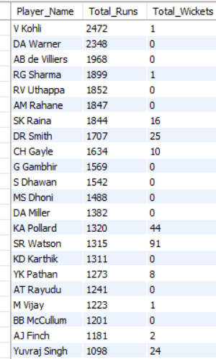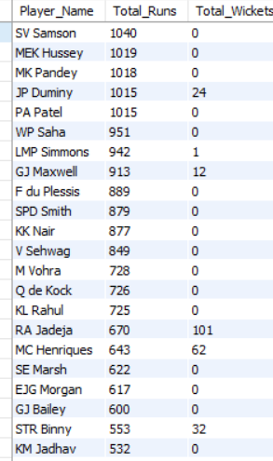

1. Approach:-
The analysis combines batting and bowling performance of players by calculating Total Runs and Total Wickets. Players contributing significantly in either batting, bowling, or both are identified to recommend the best auction strategy for RCB.

2. Visualization:-
Recommended Chart: Line chart
X-axis: Total Runs / Total Wickets
Y-axis: Player Name
This chart highlights the top-performing batsmen, bowlers, and all-rounders, making it easier to identify players worth targeting or retaining before the mega auction.

3. Insights:-
Virat Kohli is the highest run scorer (2472 runs), proving he should remain the core batter.
AB de Villiers (1968 runs) and Chris Gayle (1634 runs) demonstrate the value of experienced match-winning batsmen.
Shane Watson (1315 runs, 91 wickets), Ravindra Jadeja (670 runs, 101 wickets), Kieron Pollard (1320 runs, 44 wickets) and Dwayne Bravo (423 runs, 131 wickets) are excellent all-rounders who provide balance in both departments.
Several players have scored many runs but contributed very little with the ball, indicating RCB should avoid relying only on batting strength.
Players who can contribute in multiple roles increase team flexibility and improve match-winning chances.

4. Recommendations:-
Retain reliable top-order batters such as Virat Kohli.
Prioritize experienced all-rounders who can contribute with both bat and ball.
Invest in wicket-taking bowlers to strengthen the bowling attack.
Build a balanced squad instead of focusing only on star batsmen.
Select players with consistent performance across multiple seasons for long-term success.

5. Conclusion:-
The analysis suggests that RCB should focus on building a balanced squad before the mega auction. While strong batsmen form the foundation of the team, adding quality all-rounders and dependable wicket-taking bowlers will improve team balance, increase match-winning opportunities, and strengthen RCB's chances of winning the IPL trophy.

- What do you think could be the factors contributing to the high-scoring matches and the impact on viewership and team strategies?

SELECT
m.Match_Id,
v.Venue_Name,
s.Season_Year,
t1.Team_Name AS Batting_Team,
SUM(bb.Runs_Scored) + COALESCE(SUM(er.Extra_Runs),0) AS Total_Runs
FROM ball_by_ball bb
JOIN matches m
ON bb.Match_Id = m.Match_Id
JOIN venue v
ON m.Venue_Id = v.Venue_Id
JOIN season s
ON m.Season_Id = s.Season_Id
JOIN team t1
ON bb.Team_Batting = t1.Team_Id
LEFT JOIN extra_runs er
ON bb.Match_Id = er.Match_Id
AND bb.Over_Id = er.Over_Id
AND bb.Ball_Id = er.Ball_Id
AND bb.Innings_No = er.Innings_No
GROUP BY
m.Match_Id,
v.Venue_Name,
s.Season_Year,
t1.Team_Name
ORDER BY Total_Runs DESC;

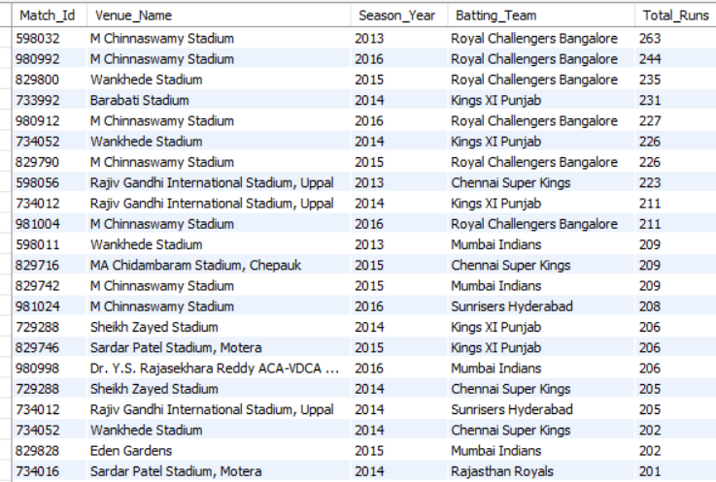

1.Approach:-
The analysis was performed by calculating the total runs scored by each batting team in every match and combining it with the venue and season information. This approach helps identify high-scoring matches, batting-friendly venues, and the teams that consistently posted large totals. The results were then analyzed to understand the factors influencing high-scoring matches and their impact on team strategies and audience engagement.

2. Visualization:-
Recommended Chart: Line Chart
X-Axis: Batting Team
Y-Axis: Total Runs
Legend: Venue Name
Reason:
A clustered line chart makes it easy to compare the total runs scored by different teams across various venues and quickly highlights the highest-scoring matches.

3. Insights:-
Royal Challengers Bangalore recorded the highest total of 263 runs, indicating exceptional batting performance.
M. Chinnaswamy Stadium appears multiple times among the highest-scoring matches, suggesting it is a batting-friendly venue.
Teams such as Kings XI Punjab, Chennai Super Kings, Mumbai Indians, and Sunrisers Hyderabad also scored more than 200 runs, reflecting aggressive batting strategies.
Most high-scoring matches were recorded during the 2013–2016 seasons.
Batting-friendly pitches, powerful top-order batsmen, and aggressive finishing in the death overs were the major contributors to these high totals.

4. Recommendations:-
Build a strong top-order batting lineup capable of maximizing the powerplay overs.
Select aggressive finishers who can accelerate scoring in the final overs.
Develop venue-specific strategies based on historical scoring patterns.
Strengthen the bowling attack, especially death-over bowling, to defend high totals.
Use performance analytics to identify batting-friendly venues and optimize team selection accordingly.

5. Conclusion:-
The analysis indicates that strong batting line-ups, batting-friendly venues, and aggressive scoring strategies are the primary factors contributing to high-scoring matches. These matches enhance fan engagement and viewership while encouraging teams to adopt more attacking batting strategies and improve their bowling plans to remain competitive.

- Analyze the impact of home-ground advantage on team performance and identify strategies to maximize this advantage for RCB.

SELECT
t.Team_Name,
v.Venue_Name,
COUNT(*) AS Matches_Played,
SUM(CASE WHEN m.Match_Winner = t.Team_Id THEN 1 ELSE 0 END) AS Wins,
ROUND(
SUM(CASE WHEN m.Match_Winner = t.Team_Id THEN 1 ELSE 0 END) * 100.0
/ COUNT(*), 2
) AS Win_Percentage
FROM matches m
JOIN team t
ON t.Team_Id IN (m.Team_1, m.Team_2)
JOIN venue v
ON m.Venue_Id = v.Venue_Id
WHERE t.Team_Name LIKE '%Bangalore%'
GROUP BY t.Team_Name, v.Venue_Name
ORDER BY Win_Percentage DESC;

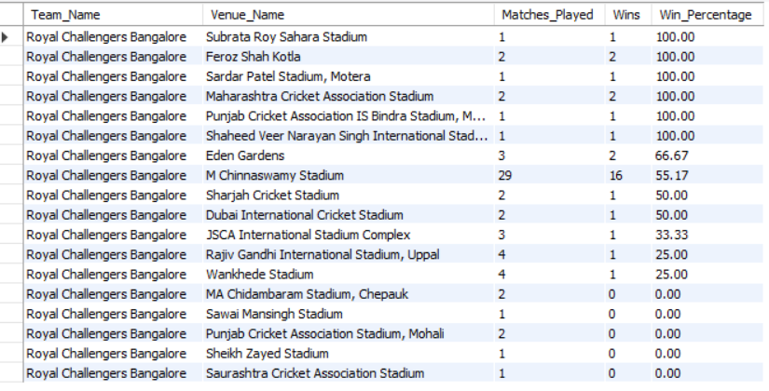

1.Approach:-
The analysis evaluates RCB's performance across different venues by calculating:
Matches Played
Matches Won
Win Percentage
This helps identify the venues where RCB performs best and where improvements are required.

2. Visualization:-
Recommended Chart: Bar Chart
X-Axis: Venue Name
Y-Axis: Win Percentage (%)

3. Insights:-
Subrata Roy Sahara Stadium, Feroz Shah Kotla, Sardar Patel Stadium, Maharashtra Cricket Association Stadium, Punjab Cricket Association IS Bindra Stadium, and Shaheed Veer Narayan Singh International Stadium recorded a 100% win rate, although RCB played only 1–2 matches at these venues.
At M. Chinnaswamy Stadium (Home Ground), RCB played 29 matches, won 16, and achieved a 55.17% win percentage, indicating a moderate home-ground advantage.
RCB maintained a 66.67% win percentage at Eden Gardens.
The team recorded 50% win rates at Sharjah Cricket Stadium and Dubai International Cricket Stadium.
RCB struggled at venues such as MA Chidambaram Stadium, Sawai Mansingh Stadium, Punjab Cricket Association Stadium (Mohali), Sheikh Zayed Stadium, and Saurashtra Cricket Association Stadium, where the win percentage was 0%.

4. Recommendations:-
Strengthen RCB's home-ground strategy at M. Chinnaswamy Stadium to increase the win percentage beyond 55%.
Build a squad suited to batting-friendly home conditions while including bowlers who can effectively defend high scores.
Analyze unsuccessful venues to understand weaknesses against specific pitch conditions and opposition teams.
Improve bowling performance during the powerplay and death overs to convert close matches into wins.
Use venue-specific team combinations based on historical performance and pitch characteristics.
Continue leveraging crowd support and familiarity with home conditions to gain a competitive advantage.

5. Conclusion:-
The analysis shows that RCB enjoys a reasonable home-ground advantage at M. Chinnaswamy Stadium, with a 55.17% win rate over a large number of matches. However, there is still significant room for improvement. By optimizing team selection, strengthening bowling, and adopting venue-specific strategies, RCB can maximize its home-ground advantage and improve its overall performance across future IPL seasons.

- Come up with a visual and analytical analysis of the RCB's past season's performance and potential reasons for them not winning a trophy.
SELECT
s.Season_Year,
COUNT(*) AS Matches_Played,
SUM(
CASE
WHEN m.Match_Winner = t.Team_Id THEN 1
ELSE 0
END
) AS Matches_Won,
ROUND(
SUM(
CASE
WHEN m.Match_Winner = t.Team_Id THEN 1
ELSE 0
END
) * 100.0 / COUNT(*), 2
) AS Win_Percentage
FROM matches m
JOIN season s
ON m.Season_Id = s.Season_Id
JOIN team t
ON t.Team_Name = 'Royal Challengers Bangalore'
WHERE t.Team_Id IN (m.Team_1, m.Team_2)
GROUP BY s.Season_Year
ORDER BY s.Season_Year;
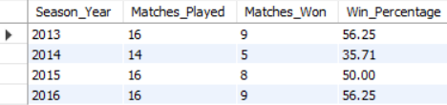

1. Approach:-
The analysis evaluates RCB's performance season-wise by calculating:
Matches Played
Matches Won
Win Percentage
The objective is to identify performance trends across seasons and determine why RCB could not convert good league-stage performances into an IPL title.

2. Visualization:-
Recommended Chart: Line Chart
X-Axis: Season Year
Y-Axis: Win Percentage (%)

3. Insights:-
RCB recorded its best performance in 2013 and 2016, winning 9 out of 16 matches with a 56.25% win percentage.
2015 was a relatively balanced season, with 8 wins from 16 matches and a 50% win rate.
2014 was the weakest season, where RCB won only 5 out of 14 matches, resulting in a 35.71% win percentage.
Although RCB had competitive seasons in 2013 and 2016, the team was unable to maintain consistency during crucial knockout matches.
The performance trend shows fluctuations across seasons rather than sustained improvement, making it difficult to build championship-winning momentum.

4. Recommendations:-
Improve consistency throughout the entire season instead of relying heavily on a few key players.
Build a stronger bowling attack, especially for the death overs, to defend competitive totals.
Strengthen the middle-order batting to reduce dependence on the top-order.
Develop better strategies for knockout matches by handling pressure situations more effectively.
Retain a stable core squad and make data-driven team selections based on player form and match conditions.

5. Conclusion:-
The season-wise analysis shows that RCB consistently remained a competitive team, with their highest win percentage reaching 56.25% in 2013 and 2016. However, inconsistent performances across seasons, overdependence on star players, and the inability to perform under pressure in crucial matches prevented the team from winning an IPL trophy. A balanced squad, stronger bowling unit, and improved consistency can significantly increase RCB's chances of becoming champions in future seasons.

- How would you approach this problem, if the objective and subjective questions weren't given?

1.Approach:-
I would begin by understanding the business objective and exploring the dataset through Exploratory Data Analysis (EDA). First, I would examine the tables, identify relationships, and clean the data if necessary. Then, I would analyze team performance, player performance, venue-wise statistics, season-wise trends, batting and bowling records, win percentages, toss impact, and scoring patterns. Based on these findings, I would identify meaningful business insights and recommend strategies that could help improve team performance and decision-making.

2. Visualization:-
Recommended Visualizations:
Bar Chart – Team-wise Wins
Line Chart – Season-wise Performance Trend
Pie Chart – Toss Decision Distribution
Column Chart – Top Run Scorers
Column Chart – Top Wicket Takers
Heatmap – Team vs Venue Performance
Scatter Plot – Runs vs Wickets Analysis

3. Insights:-
Identify the best-performing teams and players.
Compare batting and bowling performance across seasons.
Analyze venue-wise winning patterns and scoring trends.
Evaluate the impact of toss decisions on match outcomes.
Discover strengths and weaknesses of each team through data-driven analysis.

4. Recommendations:-
Perform complete Exploratory Data Analysis (EDA) before drawing conclusions.
Focus on KPIs such as win percentage, run rate, wickets, and venue performance.
Create interactive dashboards to monitor team and player performance.
Use historical trends to support team selection and match strategies.
Continuously validate findings with multiple performance metrics.

5. Conclusion:-
Without predefined objective or subjective questions, the best approach is to perform a structured exploratory analysis of the IPL dataset. This helps uncover hidden patterns, generate meaningful business questions, and provide data-driven insights that support better strategic decisions.

- In the "Match" table, some entries in the "Opponent_Team" column are incorrectly spelled as "Delhi_Capitals" instead of "Delhi_Daredevils". Write an SQL query to replace all occurrences of "Delhi_Capitals" with "Delhi_Daredevils".

UPDATE matches
SET Opponent_Team = 'Delhi_Daredevils'
WHERE Opponent_Team = 'Delhi_Capitals';
Output Analysis
The query updates all records where the Opponent_Team value is 'Delhi_Capitals' and replaces it with 'Delhi_Daredevils'. This corrects the incorrect team name and maintains consistent data in the table.

